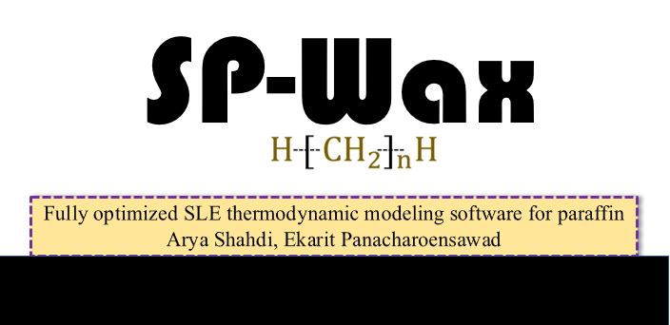

Developer’s Manual

Developed by:

Arya Shahdi

Ekarit Panacharoensawad

Contents

❖ Overview 3

❖ SP-Wax Provided Files 3

❖ Theoretical Framework 5

❖ Program Structure and Implementation 12

➢ SPWaxInt.exe 13

➢ SPWaxFn.cpp and Header.h 13

➢ SPWaxBinary (.exe & .cpp) 18

➢ SPWaxKInitialization (.exe & .cpp) 20

➢ SPWaxPrecipitation (.exe & .cpp) 22

➢ SPWaxOneTemperatureCase (.exe & .cpp) 23

➢ SPWaxCCN (.exe & .cpp) 24

❖ Validation of empirical correlations 25

➢ Molar volume correlations 25

➢ Thermo-physical properties 27

❖ Experimental data sets 30

❖ Nomenclature 34

❖ References 36

# Overview

In this manual, different aspects of SP-Wax are discussed for any potential developer. All codes are written in C-family computer language. Computation parts are in C++ and user interface is coded in C#. This combination guarantees good performance and allows everyone (technical and non-technical users) to use SP-Wax. This document can be useful for potential developers who want:

1. To improve SLE modeling of paraffin in their existing paraffine software
2. To employ certain parts of the code for specific research objectives
3. To modify SP-WAX by introducing different activity coefficients or different correlations for thermo-physical properties
4. To include this work to wax deposition modeling

# SP-Wax Provided Files

In this section, all provided files as part of SP-Wax software package are explained. SP-Wax package contains nine Folders as shown:

1

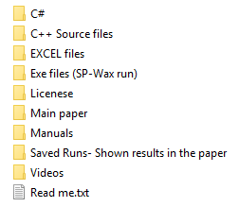

8

7

6

5

4

3

2

9

1. C#. In this folder all different parts of C# codes are included. More than 6000 lines of code have been written for C# Window Form user-friendly interface. “waxPrecipitationFinalFormat.csproj” can be opened and run in Microsoft Visual Studio. Please make sure that all required exe and txt files are present in either Debug or Release folders to be able to run. Those files are available in “Exe files (SP-Wax run)”. All sources files (.cs) are explained by many lines of comments.
2. C++ Source file. In this folder, all source files of SP-Wax are included. In SP-Wax, computations are performed in C++ so, thermodynamic modeling is calculated through .cpp files. Later in this manual, each of source files is thoroughly explained.
3. EXCEL files. In this folder, there are two EXCEL files that contain in-depth analysis of different parameters. “SP-Wax Results.xlsx” contain numerical values of all graphs in the main paper. “Correalation Validation.xlsx”, in this EXCEL file, used correlations in SP-Wax have been analyzed and verified by some experimental data. The analyzed properties are: enthalpy and temperature of solid-phase transition, enthalpy and temperature of fusion, enthalpy of vaporization, and molar volume,
4. Exe files (SP-Wax run). In this folder, SP-Wax should be run because all required files are available. The following picture shows the requires files which have to be present in the same directory for SP-Wax simulation run.

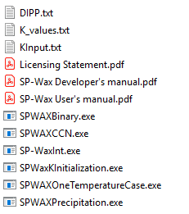

SP-WaxInt.exe directs users to the software interface

1. (Un)licensing statement
2. Main paper
3. Manuals. Two user’s manual and developer’s manual are provided.
4. Saved Runs- Shown results in the paper. In this file, saved SP-Wax run files are included. Please note that all graphs and outputs in the main paper are from simulation runs in this folder. For more analysis of outputs, please refer to “SP-Wax Results.xlsx”. In other words, all provided outputs can be reproduced by saved files from this folder.
5. One video is provided to show the functionalities of SP-Wax and to show how to run it.

# Theoretical Framework

Weight fractions of precipitated wax at different temperatures are calculated and plotted. Generated curve is called precipitation curve and it is different for different oil compositions. The first important input data is composition of n-alkane components ($z_{i}$). Provided compositions should be in mole fraction and summation of all compositions should add up to unity. SP-Wax can only predict characteristics of n-alkane system. Therefore, composition of the total fluid is not required. User should only provide the weight percentage of n-alkanes in the total fluid ($W_{NA}$). Eq- 1 to Eq- 3 are used to calculate precipitated mole fraction ($n_{s}$) and compositions of liquid and solid phases for n-alkane system. Then, Eq- 6 is used to calculate weight fraction of precipitated phase in the total fluid ($WF)$.

In the first step, set of initial values for equilibrium constants are calculated and provided. Please note that the convergence problem is mainly due to incorrect initial guesses of $k_{i}$ values. In SP-Wax, there is an executable file (SPWaxKInitialization.exe) which provides equilibrium constant values. These values are used as initial guesses for equilibrium constants. This excludes any possibility of convergence problem. After choosing initial values for equilibrium constants, three following equations are used to calculate precipitated wax fraction, solid and liquid phase compositions [1].

|  |  |
| --- | --- |
| $$\sum_{i=1}^{i=N}{\left(z_{i}*\frac{K_{i}- 1}{1 + n_{s}*\left(K_{i}- 1\right)}\right)}=0$$ | Eq- 1 |
| $$x_{i}^{L}=\frac{z_{i}}{1+n_{s}*\left(K_{i}-1\right)}$$ | Eq- 2 |
| $$x_{i}^{S}=\frac{z_{i}*K_{i}}{1+n_{s}*\left(K_{i}-1\right)}$$ | Eq- 3 |

After determining $n_{s},x_{i}^{L}and x_{i}^{S}$ for all carbon numbers. Activity coefficients are calculated using Entropic-free-volume and Wilson models for liquid and solid phases respectively. Please note that activity coefficients are dependent on compositions of solid and liquid phases. After calculating $γ_{i}^{L}$ and $γ_{i}^{S}$ for all carbon number components, new equilibrium constants are calculated through Eq- 4 [2].

|  |  |
| --- | --- |
| $$K_{i}=\frac{γ_{i}^{L}}{γ_{i}^{S}}\exp\left(\frac{Δ{H_{i}}_{ }^{f}}{RT_{i}^{f}}\left(\frac{T_{i}^{f}}{T}-1\right)+\frac{Δ{H_{i}}_{ }^{t_{2}}}{RT_{i}^{t_{2}}}\left(\frac{T_{i}^{t_{2}}}{T}-1\right)-\frac{{Δ_{s}^{l}C}_{p_{i}}}{R}*\left(\frac{T_{i}^{f}}{T}-\ln\left(\frac{T_{i}^{f}}{T}\right)-1\right)\right)$$ | Eq- 4 |

Where $Δ{H_{i}}_{ }^{f},T_{i}^{f},Δ{H_{i}}_{ }^{tr},T_{i}^{tr}$ and ${Δ_{s}^{l}C}_{p_{i}}$ are thermo-physical properties and are expressed through empirical correlations (discussed later). Newly calculated $K$ values are then compared to previous equilibrium constants ($K^{C}$) through the following relation:

|  |  |
| --- | --- |
|  | Eq- 5 |

If calculated $ϵ$ is more than the desired threashold, calcualtions starts over from Eq- 1 and continues to Eq- 5. However, if calculated $ϵ$ was less than the desired error, calculations will stop and $n_{s},x_{i}^{L}and x_{i}^{S}$ are reported. Weight fraction of precipitated wax in total fluid is then calculated as:

|  |  |
| --- | --- |
| $$WF \left(Solidified wax weight fraction\right)\left[\frac{weight of solid phase}{weight of total fluid}\right]=$$ $$Σx_{i}^{s}Mw_{i}\left[\frac{weight of solid phase}{1 mole of solid phase}\right]*n_{s}\left[\frac{mole of solid phase}{1 mole of total n-alkanes }\right]$$ $$*\frac{1}{Σz_{i}Mw_{i}}\left[\frac{1 mole of total n-alkanes}{ wieght of nalkanes}\right]*W_{NA}[\frac{weight of nalkanes}{weight of total fluid}]$$ | Eq- 6 |

In the following section, activity coefficients of solid and liquid phases which are used in SP-Wax are described.

* **Liquid phase non-ideality**

|  |  |
| --- | --- |
| In SP-Wax, liquid-phase non-ideality [3] is expressed by: $$lnγ_{i}^{L}=ln\frac{ϕ_{i}}{x_{i}}+1-\frac{ϕ_{i}}{x_{i}}$$ | Eq- 7 |

Where $ϕ_{i}$ is composition fraction,

|  |  |
| --- | --- |
| $$ϕ_{i}=\frac{x_{i}S_{i}}{Σx_{j}S_{j}}$$ | Eq- 8 |

The main difference between all models is the way element $“S”$ has been defined. In SP-Wax Entropic Free-Volume model has been used and $"S"$ is defined as:

|  |  |
| --- | --- |
| $$S_{i}(Entropic)={\left(V_{m,i}^{ }-V_{w,i}^{ }\right)}^{2/3}$$ | Eq- 9 |

* **Solid phase non-ideality**

In SP-Wax, solid phase activity coefficients are calculated using Wilson method [4] as follows:

|  |  |
| --- | --- |
| $$\ln\left(γ_{i}^{s}\right)=-\ln\left(Σ_{j}Λ_{ij}x_{j}\right)+1-Σ_{j}\frac{Λ_{ji}x_{j}}{Σ_{k}Λ_{jk}x_{k}}$$ | Eq- 10 |

Where,

|  |  |
| --- | --- |
| $$Λ_{ij}=\exp\left(-\frac{λ_{ij}-λ_{ii}}{RT}\right)$$ | Eq- 11 |
| $λ_{ii}=-\frac{1}{3}(ΔH_{i}^{sub}-RT)$ | Eq- 12 |
| $$Δ^{sub}H=Δ^{vap}H+Δ^{f}H+Δ^{tr}H$$ | Eq- 13 |
| $$λ_{ij}=α_{ij}min⁡(λ_{ii},λ_{jj})$$ | Eq- 14 |

$α_{ij}$ is a correction factor that has been expressed differently in literatures. In this study, different correlations have been analyzed and following expression was chosen for correction factor. Please note that $α_{ij}$ was used in multi-component systems only. In binary systems, no correction factor was required, and model is purely predictive. In multi-component systems, correction factor is defined as:

|  |  |
| --- | --- |
|  | Eq- 15 |

Where $“a”$ is an adjustment coefficient.

In Eq- 1, thermo-physical properties are required. In this section, correlations that have been used in SP-Wax, are described.

We compared experimental data of four multi-component systems and adjusted $"a"$ for all of them. For three oil compositions where n-alkane system weight fraction were less than 0.15, $"a"$ was calculated to be $3*{10}^{-6}$. However, for the case where only n-alkanes were present ($WF=1$), very small $"a"$ (close to zero) was needed. So, we suggest using $"a"$ coefficients as follows:

$$If WF≅1, 0≤ a<8*{10}^{-7}$$

$$If 0.15<WF<1, 8*{10}^{-7} ≤ a<3*{10}^{-6}$$

$$If WF≤0.15, a=3*{10}^{-6}$$

Please note that the mentioned recommendations are based on analyzing of four multi-component systems through various parameters including precipitation curve, solid-phase composition and Critical Carbon Number (CCN). For each oil composition, all parameters were optimally predicted with one adjustment parameter at various conditions. This study is amongst very few ones that confirmed Coutinho et al. SLE model by analyzing different paraffin related parameters against experimental data. (not just by precipitation data points).

* **Thermo-physical properties**

Heat and temperature of fusion (Coutinho et al. [5]):

|  |  |
| --- | --- |
| $$T_{i}^{f}\left[K\right]=421.63-\left(421.63+1935991\right)\exp\left(-7.8945{\left(C_{n}-1\right)}^{0.07194}\right)$$ | Eq- 16 |
| $$Δ_{fus}H_{i}\left[\frac{KJ}{mol}\right]=0.00355C_{ni}^{3}-0.2376C_{ni}^{2}+7.4C_{ni}-34.814$$ | Eq- 17 |

Heat and temperature of solid phase transition (Coutinho et al. [5]):

|  |  |
| --- | --- |
| $$T^{tr}\left[K\right]=420.42-(420.42+134364)exp⁡(-4.344{\left(C_{ni}+6.592\right)}^{0.14627}$$ | Eq- 18 |
| $$Δ^{tr}H=Δ^{tr}H-Δ^{f}H$$ | Eq- 19 |
| $$Δ^{tot}H_{i}\left[\frac{KJ}{mol}\right]=3.7791C_{ni}-12.654$$ | Eq- 20 |

Heat of vaporization (Extension of Pitzer CSP models[6]):

|  |  |
| --- | --- |
| $$Δ^{vap}H \left[\frac{KJ}{mole}\right]={Δ^{vap}H}^{*}*RT_{c}$$ | Eq- 21 |
| $${Δ^{vap}H}^{*}=Δ^{vap}H_{ }^{*(0)}+ωΔ^{vap}H_{ }^{*(1)}+ω^{2}Δ^{vap}H_{ }^{*(2)}$$ | Eq- 22 |
| $$ω=0.0520750+0.0448946n-0.000185397n^{2}$$ | Eq- 23 |
| $${{Δ^{vap}H}^{*}}^{(J)}=b_{1}^{(J)}x^{0.3333}+b_{2}^{(J)}x^{0.8333}+b_{3}^{(J)}x^{1.2083}+b_{4}^{(J)}x+b_{5}^{(J)}x^{2}+b_{6}^{(J)}x^{3}$$ | Eq- 24 |
| $$x=1-T_{r}$$ | Eq- 25 |
| $$\ln\left(959.98-T_{c}\right)=6.81536-0.211145n_{c}^{\frac{2}{3}}$$ | Eq- 26 |

Where $"b"$ coefficients are:

Table 1: Coefficient table of Extension of Pitzer CSP models

|  |  |  |  |  |  |
| --- | --- | --- | --- | --- | --- |
|  | |  | | --- | |  | |  | |  | | --- | |  | |
| b1 | 5.2804 | 0.80022 | 7.2543 |
| b2 | 12.865 | 273.23 | -346.45 |
| b3 | 1.171 | 465.08 | -610.48 |
| b4 | -13.116 | -638.51 | 839.89 |
| b5 | 0.4858 | -145.12 | 160.05 |
| b6 | -1.088 | 74.049 | -50.711 |

* **Molar volume**

In liquid phase activity coefficient formulas, molar volume is needed. The following

Molar volume for ${7≤C}_{n}≤20$ (DIPPR Correlations):

|  |  |
| --- | --- |
| $$V_{m,i}[\frac{m^{3}}{Kmol}]={\left(\frac{A}{B^{\left(1+{\left(1-\frac{T}{C}\right)}^{D}\right)}}\right)}^{-1}$$ Molar volume for $C_{n}<7 \& C_{n}>20$ (GCVOL Contribution method [7]): | Eq- 27 |
| $$V_{m,i}[\frac{m^{3}}{mole}]=\frac{Σn_{i}Δv_{i}}{{10}^{6}}$$ | Eq- 28 |
| $$Δv_{i}[\frac{{cm}^{3}}{mole}]=A_{i}+B_{i}^{T}+C_{i}T^{2}$$ | Eq- 29 |

Table 2: GCVOL Coefficients

|  |  |  |  |
| --- | --- | --- | --- |
| **Comp** | **A $$[\frac{cm^{3}}{mole}]$$** | **B $$[\frac{cm^{3}}{mole °k}]$$** | **C** |
| **CH3** | $$18.96$$ | $$45.58*{10}^{-3}$$ | $$0$$ |
| **CH2** |  |  |  |

|  |  |
| --- | --- |
|  | Eq- 30 |

* **Van der Waal volume (Bondi**[8]**)**

|  |  |  |  |
| --- | --- | --- | --- |
| Table 3: Van der Waal volume | | |  |
| **Comp** | $Δv_{i}$ $[\frac{cm^{3}}{mole}]$ |
| **CH3** | 13.67 |
| **CH2** | 10.23 |

* **Parameters related to CCN and aging**

|  |  |
| --- | --- |
| ${\overset{⃑}{J}}_{i}=-D_{wo}\overset{⃑}{∇}C_{i}$ Where $\overset{⃑}{∇}C_{i}$ can be expressed as: | Eq-31 |
| $$\overset{⃑}{∇}C_{i}=C_{i}^{NA}\overset{⃑}{∇}ν+ν\overset{⃑}{∇}C_{i}^{NA}$$ Where $ϕ$ and $C_{i,NA}$ are defined as: | Eq-32 |
| $$C_{i}^{NA}=\frac{m_{i}^{NA}}{V^{NA}}$$ | Eq-33 |
| $$ν=\frac{V^{NA}}{V^{L}}=\frac{V^{NA}}{V^{NA}+V^{NA}}$$ | Eq-34 |

Where ${V_{L} and V}_{NA}$ are expressed as:

|  |  |
| --- | --- |
| $$V^{L}=V^{NA}+V^{non-NA}$$ | Eq-35 |
| $$V^{NA}=\sum_{i=1}^{i=N}{\left(V_{i}^{NA}\right)}$$ | Eq-36 |

The following flowchart is a summary of SP-Wax SLE thermodynamic software of paraffin precipitation curve.

Total weight fraction of n-alkane system

N-alkane molar composition, ${ Z}_{i}$

Next Temperature

Read initial K-values from the text file

Set $K_{i}^{C}=K_{i}^{ }$. Solve for the total number of moles in the solid phase, ns using Eq- 1

Calculate $x_{i}^{s} \& x_{i}^{L}$ for just n-alkane components (not the total fluid) from Eq- 2 and Eq- 3

$Δ{H_{i}}_{ }^{f},T_{i}^{f},Δ{H_{i}}_{ }^{tr},T_{i}^{tr}$ and ${Δ_{s}^{l}C}_{p_{i}}$.

Calculate each phase’s activity coefficients

as function of $γ_{i}^{L}=$ $f\left(x_{i}^{L}, T\right) γ_{S}=f(x_{i}^{S},T)$

New quilibrium values are calculated using Eq- 4

Calculating error: $ϵ=\frac{Σ\left|K_{i}^{C}-K_{i}\right|}{ΣK_{i}^{c}}$

No

Yes

Are all temperatures selected?

No

$ϵ<0.0001$

Yes

END

Calculate the wax weight fraction at each temperature $WF$

Figure 1:SP-Wax flowchart for calculation of precipitation curve

# Program Structure and Implementation

In SP-Wax, core computations are coded in C++ and functionality of SP-Wax is divided into four categories including 1) Binary system 2) Precipitation curve 3) One temperature SLE calculation 4) Critical Carbon Number (CCN) estimation. Last three categories are for multi-component systems. Each of four mentioned categories has its own source and executable files which are responsible for specific tasks. In the following picture, all source and executable files of SP-Wax are shown.

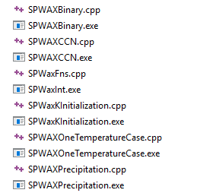

Figure 2:Source and executable files in SP-Wax (Computations of SLE model)

## SPWaxInt.exe

Communication between C++ and C# is mainly through text files. The user inserts inputs in Windows Form interface and C# generates set of text files that contain the provided inputs. When “Run Simulation” button is clicked, corresponding C++ executable file will run. The C++ exe-file requires set of inputs which have already been provided (through set of text files by C#). So, the C++ exe-file will run successfully and reports different outputs in text files. User can plot the data by clicking “Plot”. Then, C# reads the newly created text files (by C++ exe-file) and visualizes output data. This executable file is the main software that opens up SP-Wax interface for the user. This file is developed in C# and it is responsible for providing communication between the user and C++ executable files.

## SPWaxFn.cpp and Header.h

These files include the functions which have been used in SP-Wax for multi-component system SLE models.

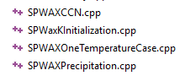

All multi-component system source files use the same functions which are defined and listed in “SPWaxFn.cpp” and “Header.h.” In SPWaxFn.cpp, more than seventy-five lines of comments are included in every step to elaborate variables and functions. In the header file, the list of functions is:

double TempFusYang(int CN);

double HeatFusYang(int CN);

double HeatFus(int CN);

double HeatTrans(int CN);

double HeatVap(double T, int CN);

double TempFus(int CN);

double TempTrans(int CN);

double *ArrayRetA();

double *ArrayRetB();

double *ArrayRetC();

double *ArrayRetD();

double Vm(double T, int CN);

double Vw(int CN);

double LambdaCorr3(int CN1, int CN2, double T, double CF);

double LambdaCorr1(int CN1, int CN2, double T, double CF);

double LambdaCorr2(int CN1, int CN2, double T, double CF);

double GammaSolid(int CN1, double X_S[], int MinC, int MaxC, double T, double CF);

double GammaSolMes(int MinC, int CN1, int CompNum, int CarbonNum[], double X_S[], double T, double CF);

double GammaLiqMesFFV(int MinC, int NumOfCN1, int CN1, int CompNum, int CarbonNum[], double X_L[], double T);

double GammaLiqMesEFV(int MinC, int NumOfCN1, int CN1, int CompNum, int CarbonNum[], double X_L[], double T);

double objFunc(double nS, int CompNum, double Z[], double K[]);

double objFuncDer(double nS, int CompNum, double Z[], double K[]);

double Fsolve(double nS, int CompNum, double Z[], double K[]);

In the following section, each function is briefly discussed

* HeatFusYang(int CN) and double TempFusYang(int CN)

These correlations are for heat and temperature of fusion for different carbon numbers. These two correlations are proposed by Yang et al.[9] However, these correlations have not been used in SP-Wax. The functions are included for potential developers to use if desired.

* HeatFus(int CN) and TempFus(int CN)

Coutinho et al.[5] proposed two correlations for temperature and enthalpy of fusion for which are used in SP-Wax. Values form these two correlations are compared to experimental data which is presented in the last chapter of this manual.

* HeatTrans(int CN) and TempTrans(int CN)

Coutinho et al.[5] also provided correlations for temperature and enthalpy of solid-phase transition. We used these two correlations in SP-Wax.

* HeatVap(double T, int CN)

Heat of vaporization is expressed through Extension of Pitzer CSP models[6]. There are uncertainties among experimental enthalpies of vaporization from different sources. Therefore, available correlations carry the mentioned uncertainties too. In this manual, we compared the predictions from CSP model with two sets of experimental vaporization enthalpy data at $T=25°C$.

* *ArrayRetA(), *ArrayRetB(), *ArrayRetC() and *ArrayRetD()

By these functions, coefficients of DIPPR molar volume correlations[10] are read from DIPP.txt which are used in SP-Wax. Following table contains coefficients for different n-alkane components for DIPPR correlations (Eq- 27).

Table 4: Coefficients of DIPPR correlations for molar volume

|  |  |  |  |  |
| --- | --- | --- | --- | --- |
| DIPPR | **A** | **B** | **C** | **D** |
| **C7** | 0.6034 | 0.2602 | 540.26 | 0.2791 |
| **C8** | 0.50864 | 0.25476 | 568.83 | 0.2694 |
| **C9** | 0.46554 | 0.25556 | 595.65 | 0.2857 |
| **C10** | 0.4129 | 0.2524 | 618.45 | 0.2857 |
| **C11** | 0.37012 | 0.24999 | 638.76 | 0.2857 |
| **C12** | 0.346 | 0.2518 | 658.2 | 0.2896 |
| **C13** | 0.3228 | 0.2504 | 675.8 | 0.312 |
| **C14** | 0.30382 | 0.25588 | 692.4 | 0.273 |
| **C15** | 0.28834 | 0.25375 | 706.8 | 0.31579 |
| **C16** | 0.27356 | 0.25442 | 720.6 | 0.3238 |
| **C17** | 0.25217 | 0.25316 | 733.37 | 0.3052 |
| **C18** | 0.2413 | 0.25763 | 745.26 | 0.274 |
| **C19** | 0.22147 | 0.25012 | 755.93 | 0.3065 |
| **C20** | 0.20966 | 0.24934 | 767.04 | 0.3088 |

* Vm(double T, int CN)

Molar volumes are calculated by DIPPR correlations[10] and GCVOL method[7].

* Vw(int CN)

Van der Waal volume which is calculated from group contribution method proposed by Bondi[8].

* LambdaCorr3(int CN1, int CN2, double T, double CF)

$Λ_{ij}$ is required in solid-phase activity coefficient calculations (Eq- 11). Energetic interaction parameter between two n-alkane are included in $Λ_{ij}$ which is expressed differently in literature. We analyzed three models in literature for $Λ_{ij}$ (LambdaCorr1[11], LambdaCorr2[9] and LambdaCorr3[12]) and included all of them in our function source file. After comparing different cases, LambdaCorr3 was used in SP-Wax with slight modification of correction factor (Eq- 11 to Eq- 14).

* Solid-phase activity coefficients

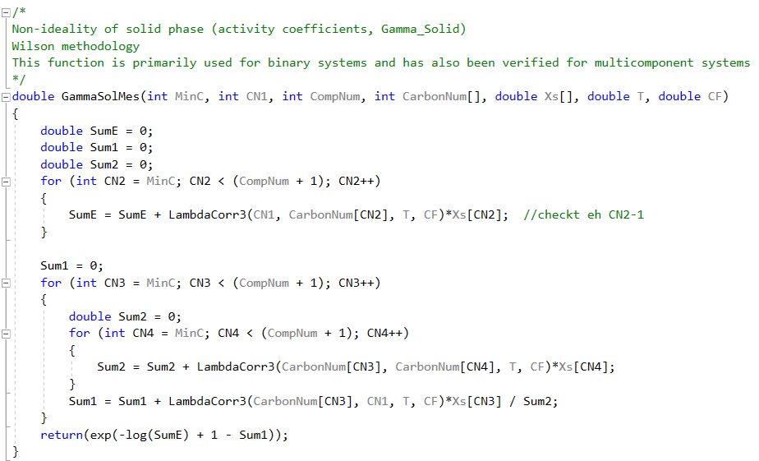For solid-phase activity coefficient, two functions are created for Wilson model. GammaSolMes (shown below) is used in SP-Wax.

Figure 3:: Solid-phase activity coefficient function used in SP-Wax

MinC: Minimum carbon number to be included in SLE calculation

CN1: Desired carbon number that activity coefficient is calculated for

CompNum: Total number of n-alkane components

CarbonNum[]: Returns carbon number

Xs[]: Solid-phase composition

T: Temperature

CF: Correction factor

* Liquid phase non-ideality

We analyzed models for liquid phase activity coefficient and found Flory-free volume[13] and Entropic free-volume[14] models to be the best candidates. Both models are included in the function source file (GammaLiqMesFFV, GammaLiqMesEFV). Although, both models are good, GammaLiqMesEFV function has been used to express liquid phase activity coefficient. Function variables are very similar to solid-phase activity coefficient function (GammaSolMes) which was thoroughly explained previously.

* objFunc(double nS, int CompNum, double Z[], double K[]);
* objFuncDer(double nS, int CompNum, double Z[], double K[]
* Fsolve(double nS, int CompNum, double Z[], double K[]);

These three functions are for Newton Raphson to find $n_{S}$.

## SPWaxBinary (.exe & .cpp)

SP-Wax is designed to work for binary and multi-component systems. SPWaxBinary.cpp and SPWaxBinary.exe are the only source and executable files for binary system case. The user provides required inputs and C# create text files which are needed for C++ executable files. The main output from binary n-alkane system is to obtain Wax Appearance Temperature (WAT) for different solute more fraction. Created text files are shown in the following picture.

1. Mole fraction of solute in the solution
   1. For different solute mole fractions, solubilities and, therefore, WAT will be different. So, it is important to provide Solute mole fractions from which WATs are required.
2. Carbon number of solvent and solute respectively. In this example, they are: $C_{7}H_{16}$ and $C_{23}H_{48}$

2

1

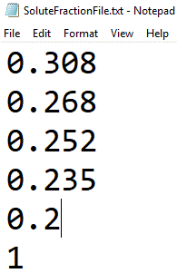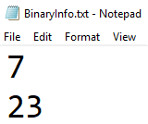

Generated source file reads one value of solute mole fraction and calculates $n_{s}$ at different temperatures till it reaches to high enough temperature that no more solid phase is formed. The corresponding temperature will be saved, and it is called WAT. Then, next value of solute mole fraction is read, and same procedure is followed. At the end, all saved WATs will be reported to a text file which is called “OutPutBinary.txt”. Please remember that DIPR.txt has to be present in the same directory as SPWaxBinary.exe too.

This source code is designed to estimate the smallest temperature at which all solute components are dissolved in liquid phase. This temperature is referred Wax Appearance Temperature (WAT). Required functions and main calculation are included in SPWaxBinary.cpp. All functions are identical to those that are used in multi-component system functions that are listed in SP-WaxFn.cpp except two functions that are specifically defined for binary system case including “BinarySys” and “BinarySysDer”. “BinarySys” calculates solid mole fraction ($n_{s}$) based on given temperature and solute mole fraction (Eq-1 to Eq-5). “BinarySysDer” calculates the derivative of “BinarySys” based on Temperature. Please refer to SPWaxBinary.cpp for more information about all other functions.

In the main section (“int main”), the general goal is to find the temperature that results in zero solid particles for function “BinarySys”. Newton Raphson was chosen to find the root which requires an initial value. There were two main difficulties that needed to be taken care of. The first one was initial value for $T$. The second problem was encountered when too high initial temperature beyond WAT was selected in Newton Raphson, “nan” was resulted and crashed the program. We found that if relatively close $T$ is chosen for initial guess, such convergence problems will disappear. So, in the main body, we followed a step-by-step procedure to find a good initial value for temperature for Newton Raphson method to find WAT. The numerical method was validated by fifty experimentally measured WAT data points. In the following picture, first two while-loops are used to find proper initial value for temperature and the third while-loop is used to find WAT.

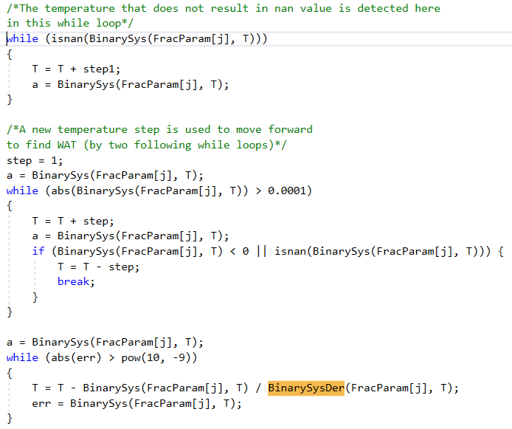

Figure 4:A snapshot of SPWaxbinary.cpp

## SPWaxKInitialization (.exe & .cpp)

In multi-component systems, convergence problem due to incorrect initial values of equilibrium constants have been resolved by SPWaxKInitialization.cpp. In this C++ source file, set of K values are generated which are used by other executable files in SP-Wax. This is

SPWaxKInitialization.cpp is a C++ source file that takes input information of the oil sample (from GeneralInput.txt) and calculates equilibrium constant values of every half temperatures ($ΔT=0.5°K$) ranging from $280.15°K$ to WAT. The calculated K values are reported in “KInitialVal.txt”. For this source file, initial values for equilibrium constants are also needed for $T=280.15°K$. There is a text file (“KInput.txt”) which includes 62 K values for $C_{1} to C_{62}$ which are used in this source file as initial values of equilibrium constant at $T=280.15°K$

Initial equilibrium constants are not only temperature dependent. They are also dependent on oil composition. In other words, for each oil composition, new equilibrium constants need to be calculated which will be used throughout other SP-Wax functionalities.

In order to run SPWaxKInitialization.exe, following files (shown below) should be in the same directory.

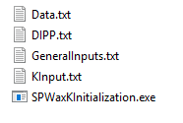

Oil composition

DIPPR molar volume coefficients

Inputs (provided in C# by the user)

Initial K values at 280.15K

When SPWaxKInitialization.exe is ran, following two text files are generated:



Where “KInitialVal.txt” is k-values for every half temperature starting from $280°K$ to WAT and “NumLine.txt” is a text file that contains total number of temperature points.

In the following graph, equilibrium constant values for different temperatures are shown. This K values are generated for Rittirong oil case (please refer to main paper for more details about this oil composition).

Figure 5: Equilibrium constant for different temperatures for Rittirong oil case

## SPWaxPrecipitation (.exe & .cpp)

This category is developed to predict precipitation curve and Wax Appearance Temperature (WAT) of provided oil composition for the desired temperature range. When input data are provided, C# produces text files that contain input data for C++ exe files. Detailed information about required inputs are discussed in SP-Wax User’s Manual. The following picture is an example of created text files as inputs to SPWaxPrecipitation.exe

1. Wax content in total fluid
2. Coefficient Adjustment
3. Minimum $C_{n}$ to be included
4. Total number of n-alkanes
5. Number of points in curve
6. Starting temperature
7. Temperature interval
8. Acceptable error
9. Acceptable error

5

6

7

8

9

2

1

3

4

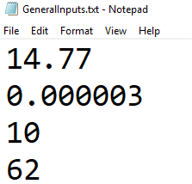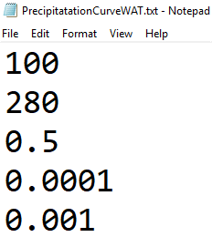

Now that inputs are provided, simulation can run to calculate precipitation curve and WAT. However, these data are not enough to run the simulator. The following graph shows the required files which should be present in the same directory for SP-Wax to run:

N-alkane mole composition

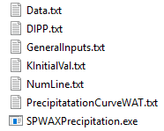

More inputs for precipitation curve prediction (provided in C# by user)

Number of temperature points in KInitialVal.txt

Initial K values generated by SPWaxKInitialization.exe

Coefficients of DIPPR for molar volumes

Inputs (provided in C# by the user)

The outputs are stored in following text files:

* WAT.txt (Wax Appearance Temperature is stored as second number)
* Wax weight fraction.txt (solid-phase fraction values)
* SolidWComposition.txt (solid-phase compositions of the temperature range)

All above outputs are visualized and plotted in the software. Please refer to SP-Wax User’s Manual for more information about output visualization.

For precipitation and WAT calculations, SP-WaxFn.cpp and Header.h are required to access to required functions in the main source file. In SPWaxPrecipitation.cpp, a major for-loop is used to iterate desired temperatures. Inside the mentioned for-loop, SLE characteristics are calculated and saved to arrays. However, if temperature passes WAT ($n_{s}$), program detects it and moves back to find WAT with desired accuracy. Since, program performs fast in higher temperatures, this method is a safe way to avoid any convergence problem.

## SPWaxOneTemperatureCase (.exe & .cpp)

This option of SP-Wax allows the user to obtain different SLE characteristics of the multi-component solution. The user provides the desired temperature and C# makes a text file with the given temperature which will be accessed by C++ executable file. The following data files are required to be in the same directory, so C++ exe file can run:

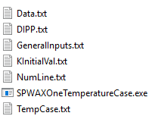

Desired temperature $°$ K

Number of temperature points in KInitialVal.txt

N-alkane mole composition

Coefficients of DIPPR for molar volumes

Inputs (provided in C# by the user)

Initial K values generated by SPWaxKInitialization.exe

The output text files are as follow:

* Wax weight fraction.txt (Solid wax fraction in total fluid)
* Concentration.txt (Relative concentration of n-alkanes in paraffin system)
  + Eq- 33
* DissolvedMass.txt (mass of n-alkanes that are dissolved in liquid phase)
* K_values.txt (equilibrium constant from the last iteration)
* LiquidMoleComposition.txt (normalized mole composition of n-alkanes in liquid phase)
* LiquidWComposition.txt (normalized weight composition of n-alkanes in liquid phase)
* SolidMoleComposition.txt (normalized mole composition of n-alkanes in solid-phase)
* SolidWCompositionOnetemp.txt (normalized weight composition of n-alkanes in solid-phase)

All above output text files are generated after running SPWaxOneTemperatureCase.exe. In SP-Wax, a combo-box has been designed that lets users choose the desired parameter to plot.

In the source code, the implementation is very similar to precipitation curve case however, it is just for one temperature rather than multiple temperatures.

## SPWaxCCN (.exe & .cpp)

CCN and aging are two concepts which are used in wax deposition phenomenon. In SP-Wax, a new parameter of relative concentration of n-alkanes is defined which is used to predict CCN. Waxy deposit is in contact with bulk fluid and with pipe’s wall with corresponding temperatures of $T_{int}$ and $T_{wall}$. In SP-Wax, relative concentrations of all n-alkanes at $T_{int}$ are subtracted from relative concentrations of all n-alkanes at $T_{wall}$. The smallest carbon number with positive relative concentration gradient value is Critical Carbon Number of CCN.

C# inserts two temperature values which are corresponded to $T_{int}$ and $T_{wall}$ to a text file. The input text file is called “TempCaseCCN.txt”. The calculated relative concentration gradients are reported in a text file which is called “ConcentrationGradient.txt”. The following picture shows that required files that need to be in the same directory to run “SPWaxCCN.exe”

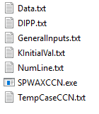

$T_{int}$ and $T_{wall}$ for Relative concentration calculation

Number of temperature points in KInitialVal.txt

Initial K values generated by SPWaxKInitialization.exe

Inputs (provided in C# by the user)

Coefficients of DIPPR for molar volumes

N-alkane mole composition

The output text file is:

* ConcentrationGradient.txt (relative concentration of all carbon numbers within n-alkane system)

This source file calculates relative concentration of n-alkanes at two given temperatures ( $T_{wall}$ and $T_{int}$). Then, relative concentrations of n-alkanes at higher and lower temperatures will be subtracted. Resulted relative concentration gradient values will be exported to the text file (ConcentrationGradient.txt)

# Validation of empirical correlations

## Molar volume correlations

In SP-Wax, molar volume has been calculated using DIPPR correlations[10] (${6<C}_{n}<21$) and GCVOL method[7] ($C_{n}>20 \& C_{n}<7$). Validity of both methods have been verified using experimental data. The two following graph shows comparison between two molar volume models and experimental data[15] for two temperatures. Both models successfully tracked experimental data while they were very similar too.

Figure 6:Molar volume comparison between experimental data of Richard et al and correlations from DIPPR and GCVOL models at T=288.15°K

Figure 7:Molar volume comparison between experimental data of Richard et al and correlations from DIPPR and GCVOL models at T=298.15°K

## Thermo-physical properties

In this section, validity of SP-Wax correlations for thermo-physical properties are evaluated and compared to experimental data.

#### Enthalpy and temperature of fusion

In SP-Wax, enthalpy and temperature of fusion are correlated by Coutinho et al.[5] using Eq- 16 and Eq- 17. In two following graphs, correlations are compared to experimental data for enthalpy and temperature of fusion. We analyzed both equations against experimental data reported by Broadhurst[16]. Fusion temperature is accurate with only 1% uncertainty while Coutinho model is not accurate in estimation of fusion enthalpy for even carbon numbers ranging from 9 to 20.

Figure 8:SP-Wax Enthalpy of fusion prediction using Coutinho et al. model correlation versus experimental data of Broadhust

Figure 9:SP-Wax Temperature of fusion prediction using Coutinho et al. model correlation versus experimental data of Broadhust

#### Enthalpy and temperature of solid-phase transition

In SP-Wax, Coutinho et al.[5] proposed correlations for enthalpy and temperature of solid-phase transition (Eq- 18 to Eq- 20) have been used. In the two following graphs, the correlations are compared to experimental data provided by Broadhurst[16]. Coutinho et al.[5] correlation accurately predicts temperature of solid-phase transition while the correlation for enthalpy of solid-phase transition shows relatively high error for even carbon numbers in the range of $22{<C}_{n}<30$.

Figure 10:SP-Wax Enthalpy of solid-phase transition prediction using Coutinho et al. model correlation versus experimental data of Broadhust

Figure 11:SP-Wax Temperature of solid-phase transition prediction using Coutinho et al. model correlation versus experimental data of Broadhust

#### Heat of vaporization

Heat of vaporization is needed to calculated heat of sublimation in solid-phase activity coefficient modeling. Extension of Pitzer CSP models[6] have been used and compared to experimental data. In the following graph, Pitzer CSP predictions are plotted against experimental data at $25° C$.[17], [18] The prediction successfully predicts $Δ^{Vap}H.$

Figure 12:CSP model prediction of vaporization enthalpy for different carbon numbers at T=25°C versus experimental data (Morawetz and Chickos et al).

# Experimental data sets

In this section, detailed information about experimental data that have been used in this study is provided. Five binary and four multicomponent systems have been evaluated using SP-Wax.

In this section, various experimentally measured properties from different sources are tabulated. We have referred to these experiments multiple times and it is beneficial to present them exclusively in one section. In binary systems, SP-WAX performance was verified by forty-nine experimentally measured WAT data points from five different systems. In multi-component systems, various aspects of SP-WAX were verified through experimental data of four different oil compositions including nineteen precipitation points, one-hundred and forty-seven solid-phase composition data and five CCN values. South Pelto[19] and Garden Banks[20] are two oil samples that have complete data of solid phase carbon number distribution and CCN. The two mentioned oil samples are evaluated through series of flowing experiments by Panacharoensawad and Rittirong. Please note that, HTGC method has been used to measure the composition of the deposit which contains solid wax particles and trapped oil. That is why the measured composition needed to be subtracted by the liquid phase composition to obtain solid phase CND. Near critical carbon number, it is difficult to differentiate between carbon numbers in liquid and solid phases. Therefore, experimentally reported CCN is just an approximation of critical carbon number.

Table 5:Binary system experimental data

|  |  |  |  |  |  |
| --- | --- | --- | --- | --- | --- |
| **System** | **Temperature, [$°$ C]** | **solute mole fraction in liquid phase** | **System** | **Temperature, [$°$ C]** | **solute mole fraction in liquid phase** |
| **n-C28 in n-C7** | 22.9 | 1.56E-02 | **n-C32 in n-C7** | 16.1 | 1.37E-03 |
| 23.75 | 1.74E-02 | 17.9 | 1.83E-03 |
| 24.3 | 2.04E-02 | 19.6 | 2.30E-03 |
| 24.55 | 2.06E-02 | 20.7 | 2.76E-03 |
| 26.2 | 2.57E-02 | 22.1 | 3.43E-03 |
| 29.15 | 3.76E-02 | 22.7 | 3.69E-03 |
| 35.2 | 7.74E-02 | 24.3 | 4.79E-03 |
| 38.8 | 1.14E-01 | 25.2 | 5.54E-03 |
| **n-C25 in n-C7** | 44.15 | 4.69E-01 | 26.55 | 6.82E-03 |
| 42.65 | 3.91E-01 | 27.9 | 8.05E-03 |
| 42.25 | 3.76E-01 | 28.4 | 8.61E-03 |
| 41.05 | 3.56E-01 | **n-C36 in n-C7** | 18.1 | 3.29E-04 |
| 37.75 | 2.57E-01 | 19 | 3.56E-04 |
| 37.25 | 2.23E-01 | 19.25 | 3.75E-04 |
| 28.25 | 1.04E-01 | 20.3 | 4.31E-04 |
| 27.55 | 9.80E-02 | 22.1 | 5.98E-04 |
| **n-C23 in n-C7** | 32.05 | 2.68E-01 | 22.9 | 6.70E-04 |
| 31.35 | 2.52E-01 | 23.25 | 7.54E-04 |
| 31.15 | 2.35E-01 | 24.4 | 9.18E-04 |
| 28.15 | 2.00E-01 | 25.8 | 1.16E-03 |
| 27.75 | 1.71E-01 | 27.1 | 1.42E-03 |
| 25.65 | 1.42E-01 | 29.25 | 2.11E-03 |
| 24.05 | 1.17E-01 | 31.4 | 2.64E-03 |
| 21.05 | 9.30E-02 | 32.65 | 3.25E-03 |
| 19.45 | 7.20E-02 | 34.1 | 4.04E-03 |
| 13.35 | 5.20E-02 |  |  |  |

Table 6: Supplementary data from Garden Banks and South Pelto oil cases

|  |  |  |  |  |  |
| --- | --- | --- | --- | --- | --- |
| **Oil Type** | **South Pelto** | **South Pelto** | **South Pelto** | **Garden Banks** | **Garden Banks** |
| **Test #** | 27 | 28 | 29 | AR-21 | AR-7 |
| **Tb [C]** | 40.55 | 40.48 | 40.33 | 25.08 | 26.02 |
| **Tw [C]** | 29.54 | 29.30 | 29.53 | 16.80 | 16.47 |
| **Ti [C]** | 37.51 | 35.99 | 34.00 | 18.01 | 19.73 |

Table 7: Experimental precipitation data

|  |  |  |
| --- | --- | --- |
| **System** | **T[$°$ C]** | **Precipitated weight fraction** |
| **Garden Banks** | 10.75 | 2.69E-03 |
| 15.00 | 2.06E-03 |
| 20.04 | 1.27E-03 |
| 25.03 | 7.64E-04 |
| 30.01 | 4.65E-04 |
| 35.00 | 0 |
| **Fleming et al.** | -10.01 | 3.08E-01 |
| -0.01 | 2.46E-01 |
| 9.99 | 1.64E-01 |
| 14.85 | 1.22E-01 |
| 19.85 | 8.14E-02 |
| 24.92 | 4.64E-02 |
| 29.93 | 1.84E-02 |
| 34.35 | 0 |
| **Zheng et al.** | 5.00 | 1.70E+00 |
| 10.00 | 1.35E+00 |
| 15.00 | 1.03E+00 |
| 20.00 | 7.48E-01 |
| 25.00 | 5.10E-01 |
| 30.00 | 3.26E-01 |
| 35.00 | 1.47E-01 |

Please refer to Rittirong for details about testing conditions. In addition, compositional input data of n-alkanes for South Pelto and Garden Banks are plotted in the next graph. For smoother CND plots, exponentially fitted lines (with $R^{2}>0.98$) have been used for composition. The effect was on precipitation curve was checked a and it is very small when fitted data were used for composition instead of actual data.

Figure 13: Compositional input data of n-alkanes for oil cases of Garden Banks and South Pelto and exponentially fitted lines

# Nomenclature

Variables

$a$ Correction factor coefficient

$C_{i}$ Concentration of ith n-alkane component

$C_{i}^{NA}$ Relative concentration of ith component within n-alkane system

$D_{wo}$ Molecular diffusivity of wax in oil, [$\frac{m^{2}}{s}$]

$H$ Enthalpy, $[\frac{J}{mol}]$

$J$ Wax mass flux [ $\frac{kg}{m^{2}.S}$]

$K$ Equilibrium constant, [-]

$K^{C}$ Equilibrium constant from previous iteration, [-]

$MW$ Molecular weight, $[\frac{kg}{mole}]$

N Number of carbon number components

$n_{s}$ Solid mole fraction or mole of solid / mole of total solution, [-]

$R$ Universal gas constant, $[\frac{J}{mol.°K}]$

$T$ Temperature, $[°K]$

$V$ Volume, $[m^{3}]$

$W_{NA}$ Weight fraction of n-alkane system in total liquid sample (paraffin and non-paraffins), [-]

$WF$ Weight fraction, [-]

$x$ Mole composition, [-]

$z$ Input mole composition of n-alkanes, [-]

${Δ_{s}^{l}C}_{p_{i}}$ Difference between specific heat capacity of $i^{th}$ component in liquid and in solid phase

Greek letters

$α$ Correction factor, [-]

$γ$ Activity coefficient, [-]

$ϵ$ Relative error, [-]

$λ$ Interaction energy parameter, $[\frac{J}{mol}]$

$ν$ Ratio of n-alkane liquid volume over total liquid volume, [-]

$ϕ$ Composition fraction, [-]

$γ_{i}^{comb}$ Combinatorial contribution in liquid phase non-ideality

Subscripts

$b$ Bulk

$Exp$ Experimental

$i$ $i^{th}$ carbon number

$int$ Interface

$j$ $j^{th}$ carbon number

$l$ Long

$m$ Molar

$s$ Short

$Sim$ Simulation

$w$ Van der Waal

Superscripts

$f$ Fusion

$L$ Liquid

$NA$ N-alkane system

$S$ Solid

$Sub$ Sublimation

$tr$ Solid-phase transition

$vap$ Vaporization

# References

[1] K. Pedersen, P. Christensen, and J. Shaikh , Phase behavior of petroleum reservoir fluids. 2014 https://goo.gl/1zB53q.

[2] J. M. Prausnitz, R. N. Lichtenthaler, and E. de Azevedo , Molecular thermodynamics of fluid-phase equilibria. 1998 http://goo.gl/EESYcN.

[3] J. Coutinho, S. Andersen, and E. Stenby , Evaluation of Activity Coefficient Models in Prediction of Alkane Solid-liquid Equilibria. Fluid Phase Equilibria. 1995 , 103 (1): 23–39 http://goo.gl/CNGpy1.

[4] J. Coutinho and E. H. Stenby , Predictive Local Composition Models for Solid/Liquid Equilibrium in n -Alkane Systems: Wilson Equation for Multicomponent Systems. Industrial & Engineering Chemistry Research. 1996 , 35 (3): 918–925 http://goo.gl/JhQg13.

[5] J. A. P. Coutinho and J.-L. Daridon , Low-Pressure Modeling of Wax Formation in Crude Oils. Energy & Fuels. 2001 , 15 (6): 1454–1460 http://goo.gl/WAoxJU.

[6] D. L. Morgan and R. Kobayashi , Extension of Pitzer CSP Models for Vapor Pressures and Heats of Vaporization to Long-chain Hydrocarbons. Fluid Phase Equilibria. 1994 , 94 51–87 http://goo.gl/JErqCJ.

[7] H. S. Elbro, A. Fredenslund, and P. Rasmussen , Group Contribution Method for The Prediction of Liquid Densities as a Function of Temperature for Solvents, Oligomers, and Polymers. Industrial & Engineering Chemistry Research. 1991 , 30 (12): 2576–2582 http://goo.gl/gaKEaE.

[8] A. Bondi , Physical Properties of Molecular Crystals Liquids, and Glasses. 1968 http://goo.gl/18sWfW.

[9] J. Yang, W. Wang, B. Shi, Q. Ma, P. Song, and J. Gong , Prediction of wax precipitation with new modified regular solution model. Fluid Phase Equilibria. 2016 , 423 128–37 http://goo.gl/9KXfYS.

[10] T. Daubert and R. Danner , Physical and thermodynamic properties of pure compounds: data compilation. 1989.

[11] J. Coutinho, K. Knudsen, and S. Andersen , A local composition model for paraffinic solid solutions. Chemical Engineering Science. 1996 , 51 (12): 3273–3282 http://goo.gl/EqMoE7.

[12] J. A. P. Coutinho, B. Edmonds, T. Moorwood, R. Szczepanski, and X. Zhang , Reliable Wax Predictions for Flow Assurance. Energy & Fuels. 2006 , 20 (3): 1081–1088 http://goo.gl/5U7WMB.

[13] P. F.-D. of the F. Society and U. 1970 , Fifteenth spiers memorial lecture. Thermodynamics of polymer solutions. pubs.rsc.org. http://goo.gl/o7k689.

[14] H. S. Elbro, A. Fredenslund, and P. Rasmussen , A new simple equation for the prediction of solvent activities in polymer solutions. Macromolecules. 1990 , 23 (21): 4707–4714 http://goo.gl/2d73mn.

[15] J. J. Marano and G. D. Holder , General Equation for Correlating the Thermophysical Properties of n -Paraffins, n -Olefins, and Other Homologous Series. 2. Asymptotic Behavior Correlations for PVT Properties. Industrial & Engineering Chemistry Research. 1997 , 36 (5): 1895–1907 http://goo.gl/tCgEwX.

[16] M. G. Broadhurst , An Analysis of The Solid Phase Behavior of The Normal Paraffins. Journal of Research of The National Bureau of Standards. 1962 , 241–249 http://goo.gl/axg2mB.

[17] J. Chickos, W. H.-J. of C. & Engineering, and U. 2004 , Vapor Pressures and Vaporization Enthalpies of the n-Alkanes from C31 to C38 at T = 298.15 K by Correlation Gas Chromatography. ACS Publications. 2004 , 49 (1): 77–85 http://goo.gl/Kb88Fr.

[18] E. Morawetz , Enthalpies of vaporization of n-alkanes from C12 to C20. The Journal of Chemical Thermodynamics. 1994 , 1 (2): 139–144 http://goo.gl/UsphqV.

[19] E. Panacharoensawad , Wax deposition under two-phase oil-water flowing conditions. Ph.D. Dissertation, University of Tulsa. 2012 , http://goo.gl/JzL1nw.

[20] A. Rittirong , Paraffin Deposition Under Two-Phase Gas-oil Slug Flow in Horizontal Pipes. Ph.D. Dissertation, University of Tulsa. 2014 , http://goo.gl/ja7G1F.